# Lab: CSS Presentation and Positioning

Problems for exercises and homework for the ["HTML and CSS" course @ SoftUni](https://softuni.bg/courses/web-fundamentals-html5). Submit your solutions in the SoftUni judge system at <https://judge.softuni.bg/Contests/406/Lab-CSS-Presentation-and-Positioning>.

## Briard History

Create a Web Page like the following.

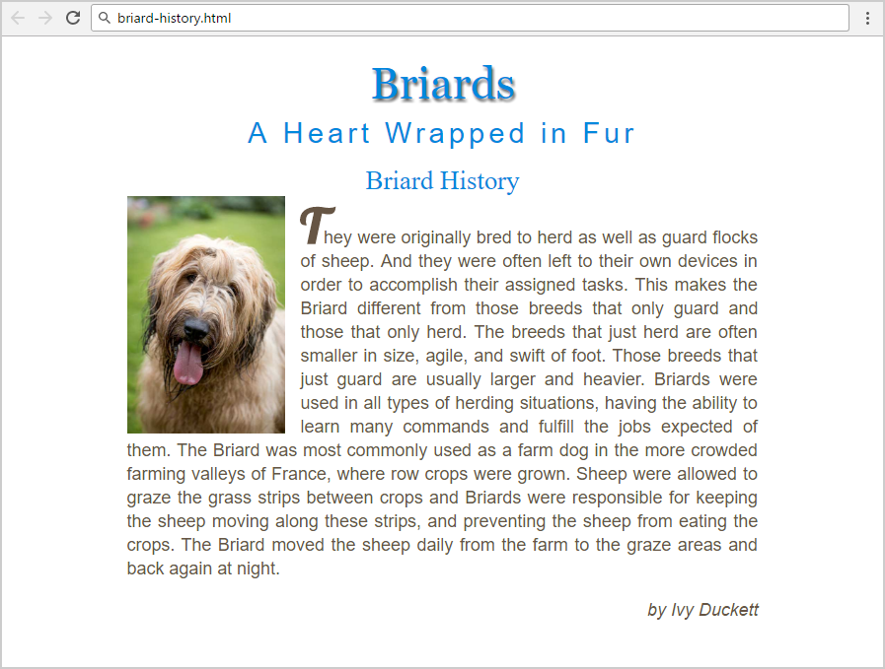

Create files: "**briard-history.css**" and "**briard-history.html**"

### Steps to Follow

Start with the **site header**:

* Copy the CSS @import for the ‘**Lobster**’ **font** from Google Fonts: [**https://fonts.googleapis.com/css?family=Lobster**](https://fonts.googleapis.com/css?family=Lobster)
* <html>
  + Text size: 16px;
* Main site
  + Center the main
  + Width: 800px;
  + Padding: 20px;
* Format the image: <img>
  + Width: 200px;
  + Float: Left;
  + Margin-right: 20px;

Test the site in the browser:

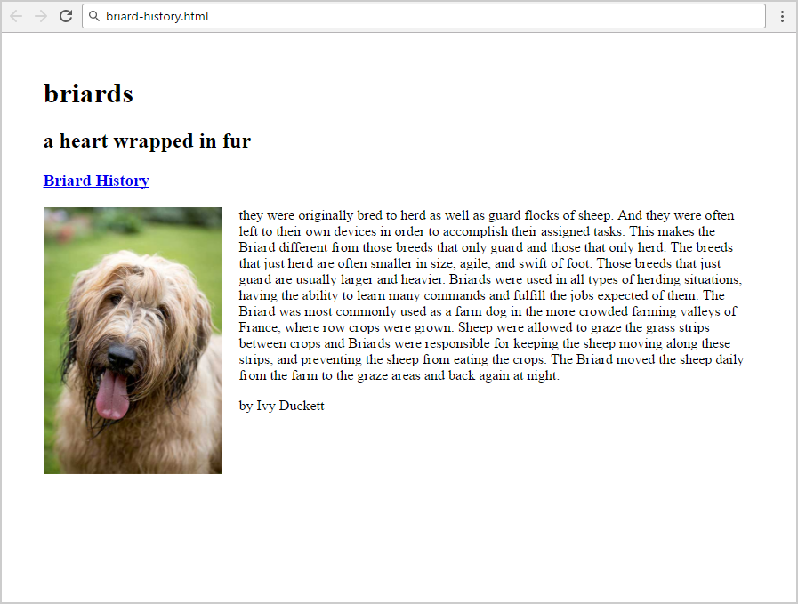

Now style the all headings and the hyperlink:

* <h1>, <h2>, <h3>, a
  + Font Style: **Normal;**
  + Text color: **#0088dd;**
  + Margin: **0;**
  + Center the text
  + Text Size: **2.1rem;**
  + Remove **underline;**
* **<h1>**
  + Font Family: **Georgia, Times, serif;**
  + Text Size: **3.5rem;**
  + Shadow for Text: **2px 4px 4px #666666;**
  + Padding at the bottom: **10px;**
  + Transform the text
* **<h2>**
  + Font Family: **Arial, sans-serif;**
  + Text Size: **2.3rem;**
  + Transform the text
  + Spacing between letter: **0.3rem;**
* **<h2> <span>**
  + Transform the text to **none**

Test the site in the browser:

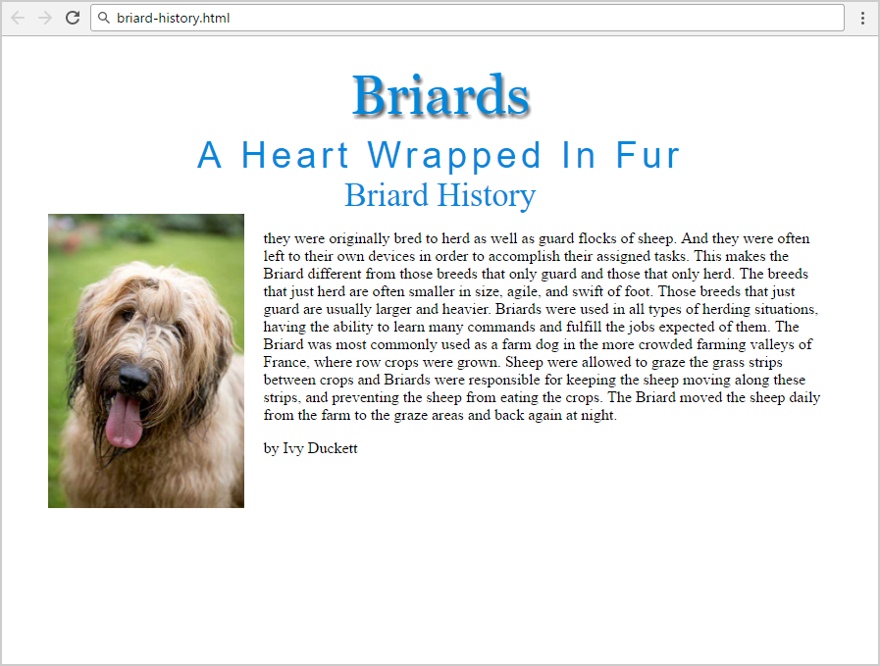

Now style the site content (article):

* **Article**
  + Margin at the top: **20px;**
  + Align Text: **Justify;**
* **Paragraphs in the article**
  + Font Family: **Arial, Verdana, sans-serif;**
  + Text Size: **1.4rem;**
  + Line Height: **30px;**
  + Text Color: **#665544;**
* **<p> for site author**
  + Text Style: **Italic;**
  + Align the text to the **right;**
* **First letter in the first article’s paragraph**
  + Text Site: **3.8rem;**
  + Font Family**: 'Lobster', cursive;**
  + Text Style: **bold;**
  + Make the text **UPPERCASE;**
  + **Hint**: use the pseudo-selector :first-of-type:first-letter

**Test** the site



Now the site is styled completely. **Submit** your solution in the **SoftUni judge**:

